CS 2265- Java Program #4

Change Log:
-Added manual input for the employee objects in main method.
-Enlarged constructors and parameters in necessary classes to allow for birthDate and its values.
-Created constructors for birthDate in Employee class.
-Altered the toString so it properly displays Date on output.
-created getMonth function in Date class, so that the date can be retrieved for verification.
-Changed order of output for individual Employee processing in main method to fit specifications.
-Enlarged employee array in PayrollSystemTest class and changed their order to specifications.
-Altered final earnings output so that it displays total monthly earnings, including possible bonus

Pictures of code in IDE:
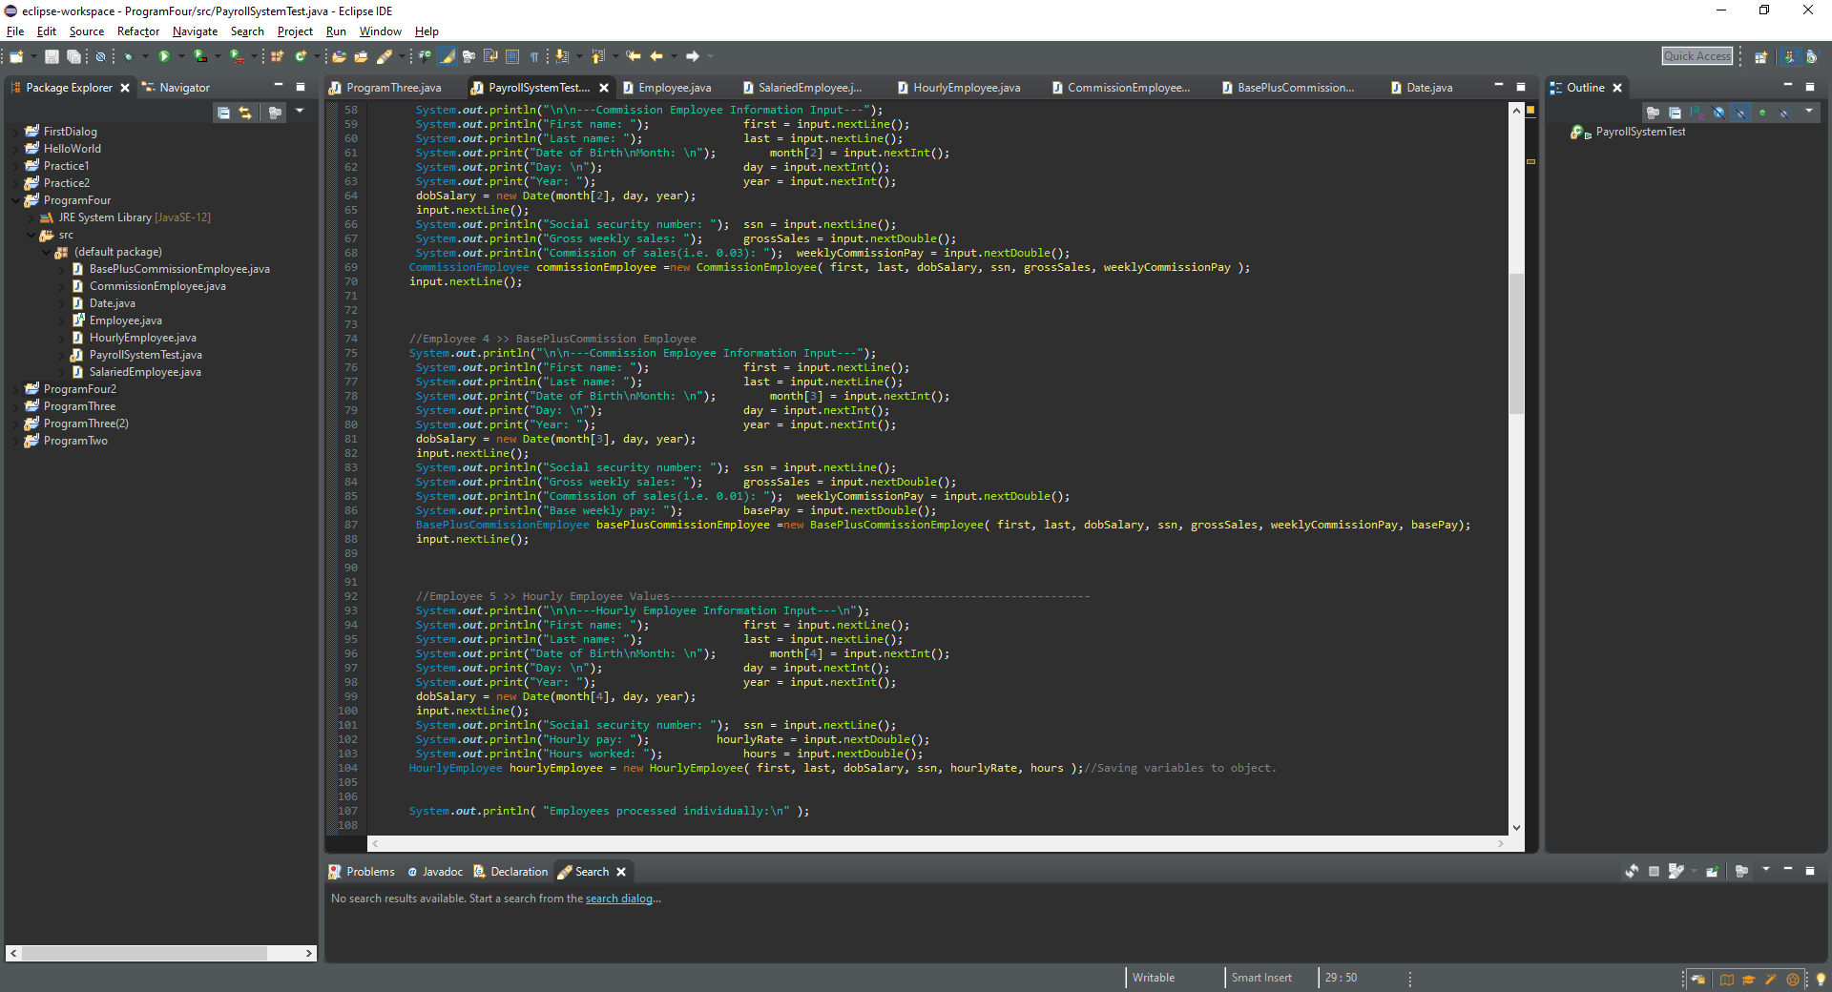

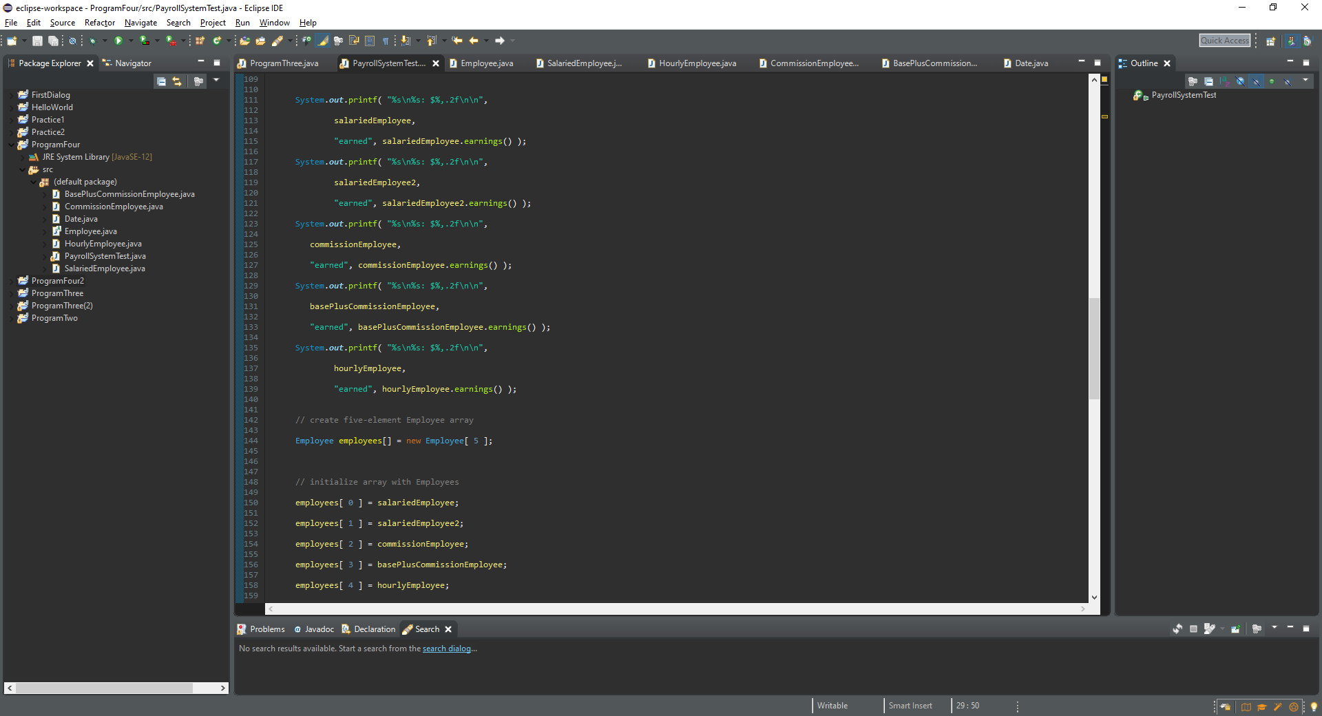

Inputing data through console pictures:
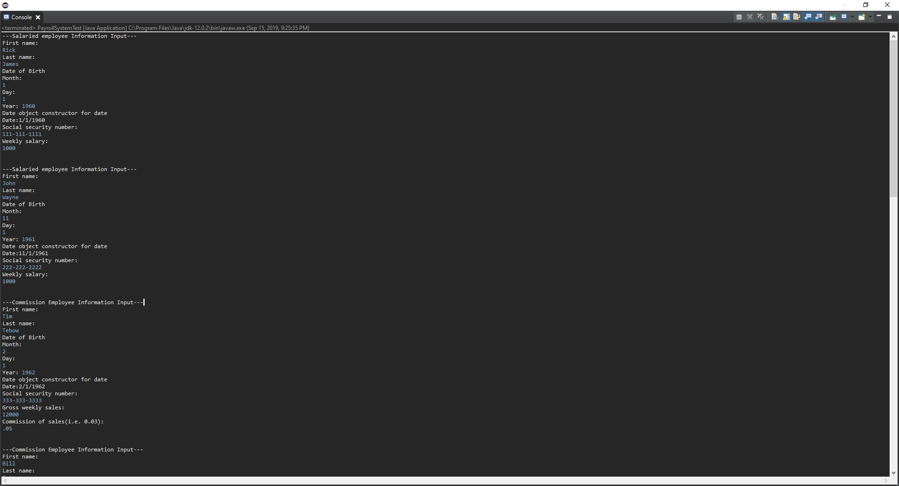

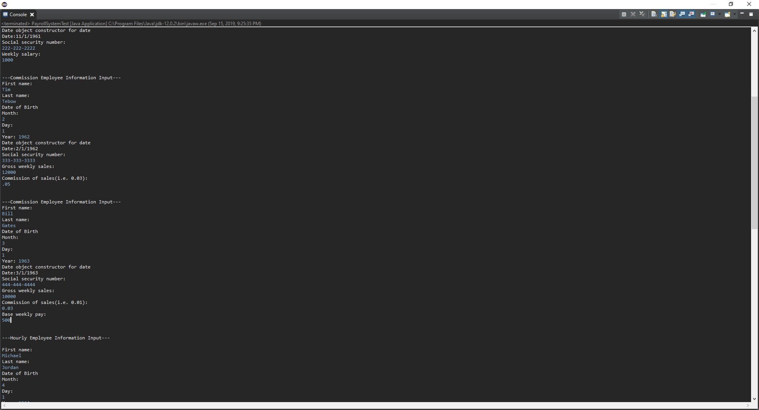
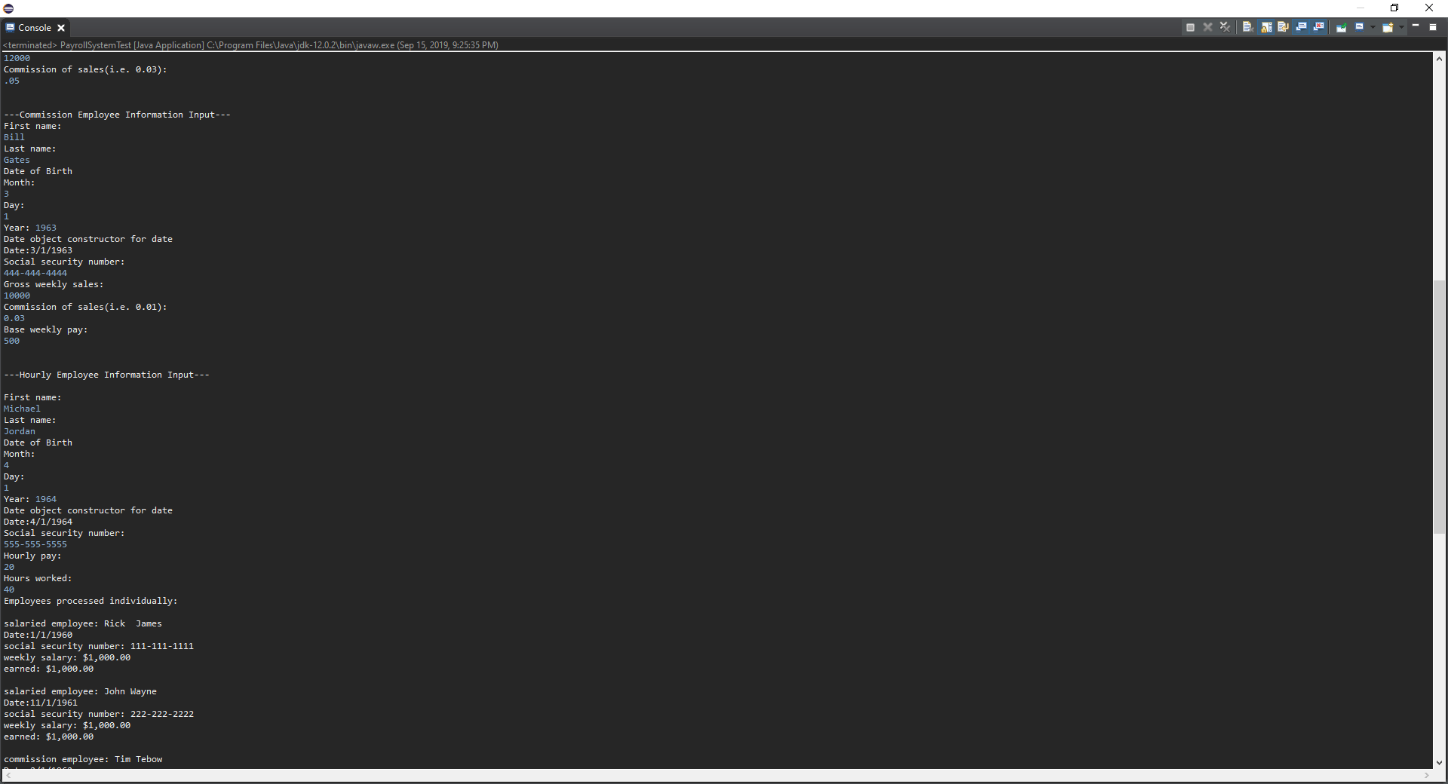

Output pictures:
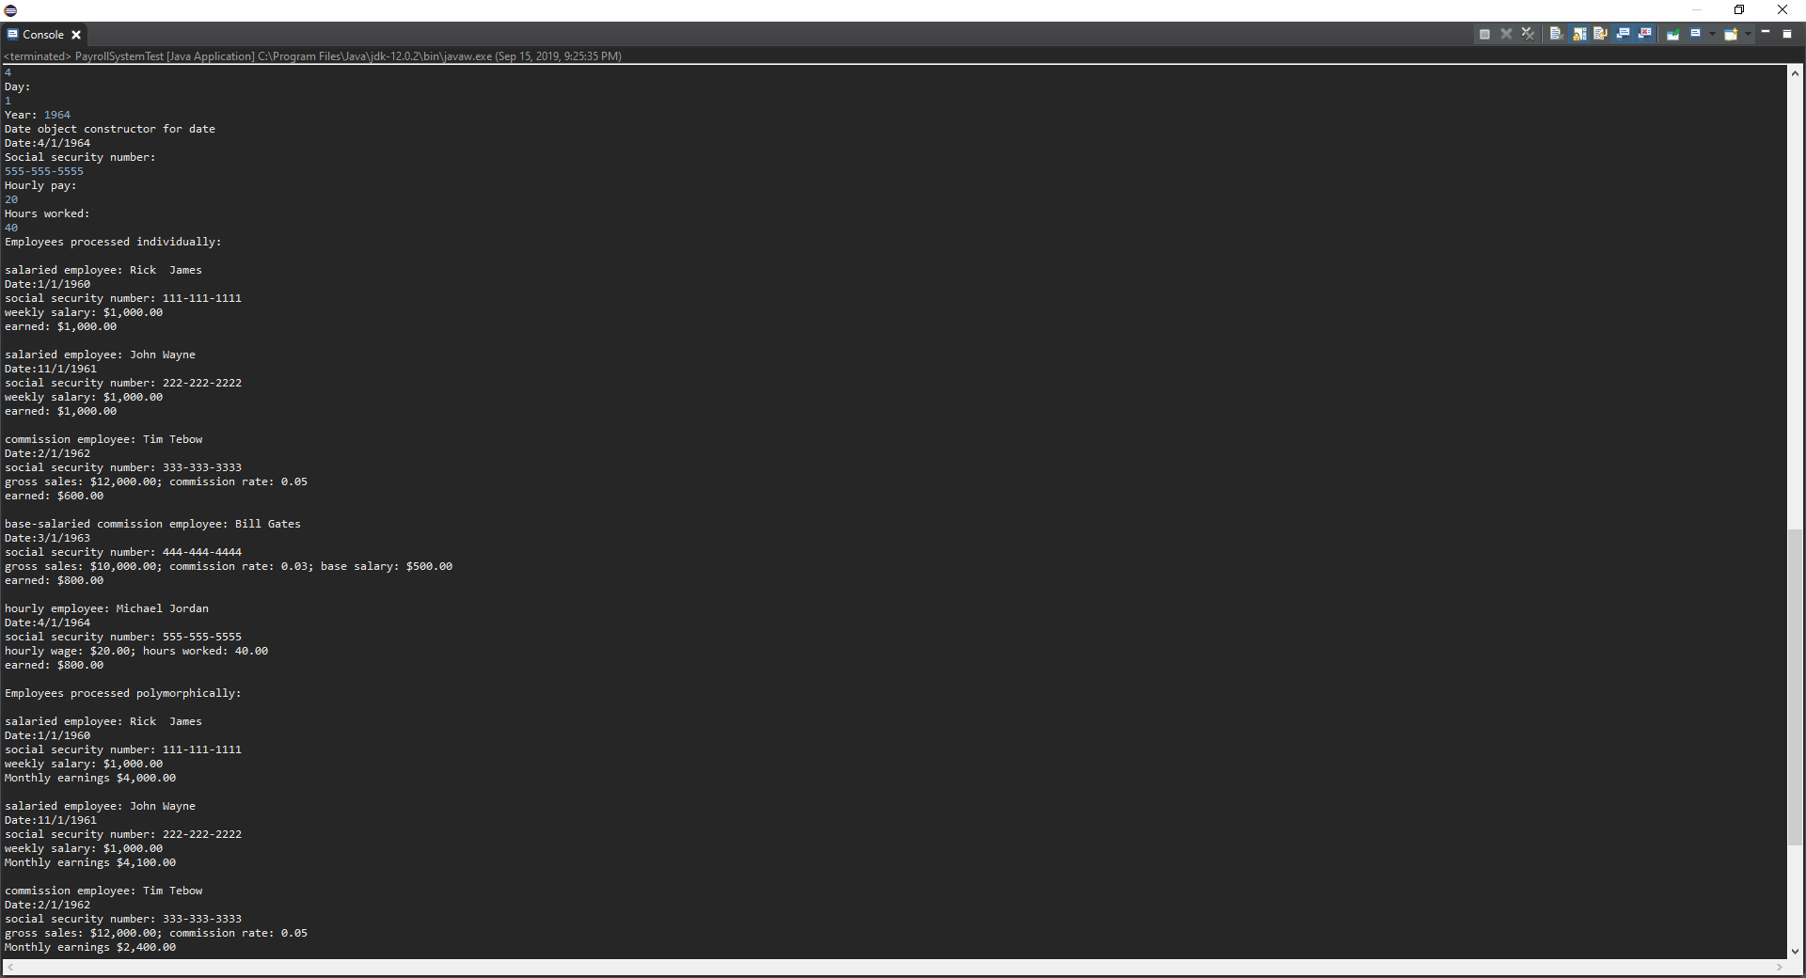

The picture below contains the polymorphically processed employee data. It includes the monthly bonus inside their total monthly pay if they meet the conditions.

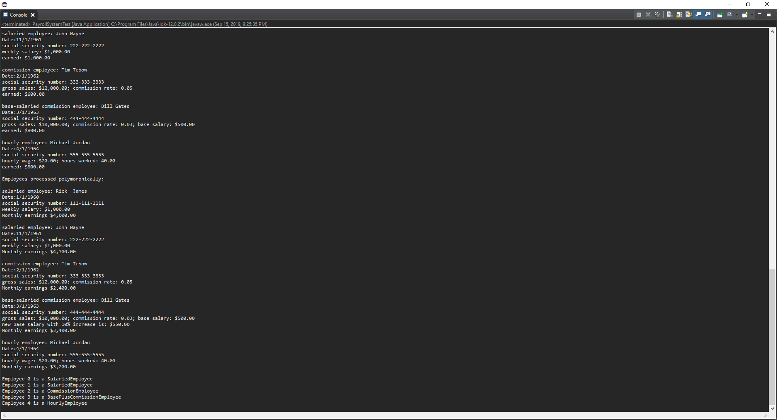

The Code
PayrollSystemTest.java

import java.util.Scanner;

// PayrollSystemTest.java

// Employee hierarchy test program.

public class PayrollSystemTest

{

public static void main( String args[] )

{
//Placeholder variable declarations
Scanner input = new Scanner(System.in);
String first, last, ssn;
double basePay, weeklyPay, weeklyCommissionPay, hourlyRate, hours, grossSales;
int month[] = new int[5];
int day, year;
int bonusMonth = 11;

// create subclass objects
//Employee 1 >> Salary Employee Values--------------------------------------------------------------------
System.out.println("---Salaried employee Information Input---");
System.out.println("First name: "); first = input.nextLine();//collects first name
System.out.println("Last name: "); last = input.nextLine(); //collects last name
System.out.print("Date of Birth\nMonth: \n"); month[0] = input.nextInt();//saves the month
System.out.print("Day: \n"); day = input.nextInt();//saves day
System.out.print("Year: "); year = input.nextInt();//saves year... month day and year will be saved to the Date object.
Date dobSalary = new Date(month[0], day, year);
input.nextLine();//Clears scanner
System.out.println("Social security number: "); ssn = input.nextLine();//Retrieves the SS number.
System.out.println("Weekly salary: "); weeklyPay = input.nextDouble();
SalariedEmployee salariedEmployee = new SalariedEmployee( first, last, dobSalary, ssn, weeklyPay);//Saving Variables to object.
input.nextLine();

//Employee 2 >> Salary Employee Values--------------------------------------------------------------------
System.out.println("\n\n---Salaried employee Information Input---");
System.out.println("First name: "); first = input.nextLine();
System.out.println("Last name: "); last = input.nextLine();
System.out.print("Date of Birth\nMonth: \n"); month[1] = input.nextInt();
System.out.print("Day: \n"); day = input.nextInt();
System.out.print("Year: "); year = input.nextInt();
dobSalary = new Date(month[1], day, year);
input.nextLine();
System.out.println("Social security number: "); ssn = input.nextLine();
System.out.println("Weekly salary: "); weeklyPay = input.nextDouble();
SalariedEmployee salariedEmployee2 = new SalariedEmployee( first, last, dobSalary, ssn, weeklyPay);//Saving Variables to object.
input.nextLine();

//Employee 3 >> Commission Employee------------------------------------------------------------------
System.out.println("\n\n---Commission Employee Information Input---");
System.out.println("First name: "); first = input.nextLine();
System.out.println("Last name: "); last = input.nextLine();
System.out.print("Date of Birth\nMonth: \n"); month[2] = input.nextInt();
System.out.print("Day: \n"); day = input.nextInt();
System.out.print("Year: "); year = input.nextInt();
dobSalary = new Date(month[2], day, year);
input.nextLine();
System.out.println("Social security number: "); ssn = input.nextLine();
System.out.println("Gross weekly sales: "); grossSales = input.nextDouble();
System.out.println("Commission of sales(i.e. 0.03): "); weeklyCommissionPay = input.nextDouble();
CommissionEmployee commissionEmployee =new CommissionEmployee( first, last, dobSalary, ssn, grossSales, weeklyCommissionPay );
input.nextLine();

//Employee 4 >> BasePlusCommission Employee
System.out.println("\n\n---Base Plus Commission Employee Information Input---");
System.out.println("First name: "); first = input.nextLine();
System.out.println("Last name: "); last = input.nextLine();
System.out.print("Date of Birth\nMonth: \n"); month[3] = input.nextInt();
System.out.print("Day: \n"); day = input.nextInt();
System.out.print("Year: "); year = input.nextInt();
dobSalary = new Date(month[3], day, year);
input.nextLine();
System.out.println("Social security number: "); ssn = input.nextLine();
System.out.println("Gross weekly sales: "); grossSales = input.nextDouble();
System.out.println("Commission of sales(i.e. 0.01): "); weeklyCommissionPay = input.nextDouble();
System.out.println("Base weekly pay: "); basePay = input.nextDouble();
BasePlusCommissionEmployee basePlusCommissionEmployee =new BasePlusCommissionEmployee( first, last, dobSalary, ssn, grossSales, weeklyCommissionPay, basePay);
input.nextLine();

//Employee 5 >> Hourly Employee Values---------------------------------------------------------------
System.out.println("\n\n---Hourly Employee Information Input---\n");
System.out.println("First name: "); first = input.nextLine();
System.out.println("Last name: "); last = input.nextLine();
System.out.print("Date of Birth\nMonth: \n"); month[4] = input.nextInt();
System.out.print("Day: \n"); day = input.nextInt();
System.out.print("Year: "); year = input.nextInt();
dobSalary = new Date(month[4], day, year);
input.nextLine();
System.out.println("Social security number: "); ssn = input.nextLine();
System.out.println("Hourly pay: "); hourlyRate = input.nextDouble();
System.out.println("Hours worked: "); hours = input.nextDouble();
HourlyEmployee hourlyEmployee = new HourlyEmployee( first, last, dobSalary, ssn, hourlyRate, hours );//Saving variables to object.

System.out.println( "Employees processed individually:\n" );

System.out.printf( "%s\n%s: $%,.2f\n\n",

salariedEmployee,

"earned", salariedEmployee.earnings() );

System.out.printf( "%s\n%s: $%,.2f\n\n",

salariedEmployee2,

"earned", salariedEmployee2.earnings() );

System.out.printf( "%s\n%s: $%,.2f\n\n",

commissionEmployee,

"earned", commissionEmployee.earnings() );

System.out.printf( "%s\n%s: $%,.2f\n\n",

basePlusCommissionEmployee,

"earned", basePlusCommissionEmployee.earnings() );

System.out.printf( "%s\n%s: $%,.2f\n\n",

hourlyEmployee,

"earned", hourlyEmployee.earnings() );

// create five-element Employee array

Employee employees[] = new Employee[ 5 ];

// initialize array with Employees

employees[ 0 ] = salariedEmployee;

employees[ 1 ] = salariedEmployee2;

employees[ 2 ] = commissionEmployee;

employees[ 3 ] = basePlusCommissionEmployee;

employees[ 4 ] = hourlyEmployee;

System.out.println( "Employees processed polymorphically:\n" );

// generically process each element in array employees

for ( Employee currentEmployee : employees )

{

System.out.println( currentEmployee ); // invokes toString

if ( currentEmployee instanceof BasePlusCommissionEmployee )

{

// downcast Employee reference to

// BasePlusCommissionEmployee reference

BasePlusCommissionEmployee employee =

( BasePlusCommissionEmployee ) currentEmployee;

double oldBaseSalary = employee.getBaseSalary();

employee.setBaseSalary( 1.10 * oldBaseSalary );

System.out.printf(

"new base salary with 10%% increase is: $%,.2f\n",

employee.getBaseSalary() );

} // end if

if(currentEmployee.getBirthDate().getMonth() == bonusMonth)//Determines if the Employee is eligible for a bonus.
{
System.out.printf(

"Monthly earnings $%,.2f\n\n", ((currentEmployee.earnings() * 4)+100) );
}
else
{

System.out.printf(

"Monthly earnings $%,.2f\n\n", (currentEmployee.earnings() * 4) );

}
} // end for

// get type name of each object in employees array

for ( int j = 0; j < employees.length; j++ )

System.out.printf( "Employee %d is a %s\n", j,

employees[ j ].getClass().getName() );

} // end main

} // end class PayrollSystemTest

/**************************************************************************

* (C) Copyright 1992-2005 by Deitel & Associates, Inc. and *

* Pearson Education, Inc. All Rights Reserved. *

* *

* DISCLAIMER: The authors and publisher of this book have used their *

* best efforts in preparing the book. These efforts include the *

* development, research, and testing of the theories and programs *

* to determine their effectiveness. The authors and publisher make *

* no warranty of any kind, expressed or implied, with regard to these *

* programs or to the documentation contained in these books. The authors *

* and publisher shall not be liable in any event for incidental or *

* consequential damages in connection with, or arising out of, the *

* furnishing, performance, or use of these programs. *

*************************************************************************/

Employee.java
// Employee.java

// Employee abstract superclass.

public abstract class Employee

{

private String firstName;

private String lastName;

private String socialSecurityNumber;

private Date birthDate;

// three-argument constructor

public Employee( String first, String last, Date dateOfBirth, String ssn)

{

firstName = first;

lastName = last;

socialSecurityNumber = ssn;

birthDate = dateOfBirth;

} // end three-argument Employee constructor

// set first name

public void setFirstName( String first )

{

firstName = first;

} // end method setFirstName

// return first name

public String getFirstName()

{

return firstName;

} // end method getFirstName

// set last name

public void setLastName( String last )

{

lastName = last;

} // end method setLastName

public void setBirthDate(Date dateOfBirth)
{
birthDate = dateOfBirth;
}

public Date getBirthDate()
{
return birthDate;
}

// return last name

public String getLastName()

{

return lastName;

} // end method getLastName

// set social security number

public void setSocialSecurityNumber( String ssn )

{

socialSecurityNumber = ssn; // should validate

} // end method setSocialSecurityNumber

// return social security number

public String getSocialSecurityNumber()

{

return socialSecurityNumber;

} // end method getSocialSecurityNumber

// return String representation of Employee object

public String toString()

{

return String.format( "%s %s %s\nsocial security number: %s",

getFirstName(), getLastName(), getBirthDate(), getSocialSecurityNumber());

} // end method toString

// abstract method overridden by subclasses

public abstract double earnings(); // no implementation here

} // end abstract class Employee

/**************************************************************************

* (C) Copyright 1992-2005 by Deitel & Associates, Inc. and *

* Pearson Education, Inc. All Rights Reserved. *

* *

* DISCLAIMER: The authors and publisher of this book have used their *

* best efforts in preparing the book. These efforts include the *

* development, research, and testing of the theories and programs *

* to determine their effectiveness. The authors and publisher make *

* no warranty of any kind, expressed or implied, with regard to these *

* programs or to the documentation contained in these books. The authors *

* and publisher shall not be liable in any event for incidental or *

* consequential damages in connection with, or arising out of, the *

* furnishing, performance, or use of these programs. *

*************************************************************************/

SalariedEmployee.java
// SalariedEmployee.java

// SalariedEmployee class extends Employee.

public class SalariedEmployee extends Employee

{

private double weeklySalary;

// four-argument constructor

public SalariedEmployee( String first, String last, Date dateOfBirth, String ssn,

double salary )

{

super( first, last, dateOfBirth, ssn ); // pass to Employee constructor

setWeeklySalary( salary ); // validate and store salary

} // end four-argument SalariedEmployee constructor

// set salary

public void setWeeklySalary( double salary )

{

weeklySalary = salary < 0.0 ? 0.0 : salary;

} // end method setWeeklySalary

// return salary

public double getWeeklySalary()

{

return weeklySalary;

} // end method getWeeklySalary

// calculate earnings; override abstract method earnings in Employee

public double earnings()

{

return getWeeklySalary();

} // end method earnings

// return String representation of SalariedEmployee object

public String toString()

{

return String.format( "salaried employee: %s\n%s: $%,.2f",

super.toString(), "weekly salary", getWeeklySalary() );

} // end method toString

} // end class SalariedEmployee

/**************************************************************************

* (C) Copyright 1992-2005 by Deitel & Associates, Inc. and *

* Pearson Education, Inc. All Rights Reserved. *

* *

* DISCLAIMER: The authors and publisher of this book have used their *

* best efforts in preparing the book. These efforts include the *

* development, research, and testing of the theories and programs *

* to determine their effectiveness. The authors and publisher make *

* no warranty of any kind, expressed or implied, with regard to these *

* programs or to the documentation contained in these books. The authors *

* and publisher shall not be liable in any event for incidental or *

* consequential damages in connection with, or arising out of, the *

* furnishing, performance, or use of these programs. *

*************************************************************************/

HourlyEmployee.java
// HourlyEmployee.java

// HourlyEmployee class extends Employee.

public class HourlyEmployee extends Employee

{

private double wage; // wage per hour

private double hours; // hours worked for week

// five-argument constructor

public HourlyEmployee( String first, String last, Date birthDate, String ssn,

double hourlyWage, double hoursWorked )

{

super( first, last, birthDate, ssn );

setWage( hourlyWage ); // validate and store hourly wage

setHours( hoursWorked ); // validate and store hours worked

} // end five-argument HourlyEmployee constructor

// set wage

public void setWage( double hourlyWage )

{

wage = ( hourlyWage < 0.0 ) ? 0.0 : hourlyWage;

} // end method setWage

// return wage

public double getWage()

{

return wage;

} // end method getWage

// set hours worked

public void setHours( double hoursWorked )

{

hours = ( ( hoursWorked >= 0.0 ) && ( hoursWorked <= 168.0 ) ) ?

hoursWorked : 0.0;

} // end method setHours

// return hours worked

public double getHours()

{

return hours;

} // end method getHours

// calculate earnings; override abstract method earnings in Employee

public double earnings()

{

if ( getHours() <= 40 ) // no overtime

return getWage() * getHours();

else

return 40 * getWage() + ( getHours() - 40 ) * getWage() * 1.5;

} // end method earnings

// return String representation of HourlyEmployee object

public String toString()

{

return String.format( "hourly employee: %s\n%s: $%,.2f; %s: %,.2f",

super.toString(), "hourly wage", getWage(),

"hours worked", getHours() );

} // end method toString

} // end class HourlyEmployee

/**************************************************************************

* (C) Copyright 1992-2005 by Deitel & Associates, Inc. and *

* Pearson Education, Inc. All Rights Reserved. *

* *

* DISCLAIMER: The authors and publisher of this book have used their *

* best efforts in preparing the book. These efforts include the *

* development, research, and testing of the theories and programs *

* to determine their effectiveness. The authors and publisher make *

* no warranty of any kind, expressed or implied, with regard to these *

* programs or to the documentation contained in these books. The authors *

* and publisher shall not be liable in any event for incidental or *

* consequential damages in connection with, or arising out of, the *

* furnishing, performance, or use of these programs. *

*************************************************************************/

CommissionEmployee.java

// CommissionEmployee.java

// CommissionEmployee class extends Employee.

public class CommissionEmployee extends Employee

{

private double grossSales; // gross weekly sales

private double commissionRate; // commission percentage

// five-argument constructor

public CommissionEmployee( String first, String last, Date birthDate, String ssn,

double sales, double rate )

{

super( first, last, birthDate, ssn );

setGrossSales( sales );

setCommissionRate( rate );

} // end five-argument CommissionEmployee constructor

// set commission rate

public void setCommissionRate( double rate )

{

commissionRate = ( rate > 0.0 && rate < 1.0 ) ? rate : 0.0;

} // end method setCommissionRate

// return commission rate

public double getCommissionRate()

{

return commissionRate;

} // end method getCommissionRate

// set gross sales amount

public void setGrossSales( double sales )

{

grossSales = ( sales < 0.0 ) ? 0.0 : sales;

} // end method setGrossSales

// return gross sales amount

public double getGrossSales()

{

return grossSales;

} // end method getGrossSales

// calculate earnings; override abstract method earnings in Employee

public double earnings()

{

return getCommissionRate() * getGrossSales();

} // end method earnings

// return String representation of CommissionEmployee object

public String toString()

{

return String.format( "%s: %s\n%s: $%,.2f; %s: %.2f",

"commission employee", super.toString(),

"gross sales", getGrossSales(),

"commission rate", getCommissionRate() );

} // end method toString

} // end class CommissionEmployee

/**************************************************************************

* (C) Copyright 1992-2005 by Deitel & Associates, Inc. and *

* Pearson Education, Inc. All Rights Reserved. *

* *

* DISCLAIMER: The authors and publisher of this book have used their *

* best efforts in preparing the book. These efforts include the *

* development, research, and testing of the theories and programs *

* to determine their effectiveness. The authors and publisher make *

* no warranty of any kind, expressed or implied, with regard to these *

* programs or to the documentation contained in these books. The authors *

* and publisher shall not be liable in any event for incidental or *

* consequential damages in connection with, or arising out of, the *

* furnishing, performance, or use of these programs. *

*************************************************************************/

BasePlusCommissionEmployee.java
// BasePlusCommissionEmployee.java

// BasePlusCommissionEmployee class extends CommissionEmployee.

public class BasePlusCommissionEmployee extends CommissionEmployee

{

private double baseSalary; // base salary per week

// six-argument constructor

public BasePlusCommissionEmployee( String first, String last, Date birthDate,

String ssn, double sales, double rate, double salary )

{

super( first, last, birthDate, ssn, sales, rate );

setBaseSalary( salary ); // validate and store base salary

} // end six-argument BasePlusCommissionEmployee constructor

// set base salary

public void setBaseSalary( double salary )

{

baseSalary = ( salary < 0.0 ) ? 0.0 : salary; // non-negative

} // end method setBaseSalary

// return base salary

public double getBaseSalary()

{

return baseSalary;

} // end method getBaseSalary

// calculate earnings; override method earnings in CommissionEmployee

public double earnings()

{

return getBaseSalary() + super.earnings();

} // end method earnings

// return String representation of BasePlusCommissionEmployee object

public String toString()

{

return String.format( "%s %s; %s: $%,.2f",

"base-salaried", super.toString(),

"base salary", getBaseSalary() );

} // end method toString

} // end class BasePlusCommissionEmployee

/**************************************************************************

* (C) Copyright 1992-2005 by Deitel & Associates, Inc. and *

* Pearson Education, Inc. All Rights Reserved. *

* *

* DISCLAIMER: The authors and publisher of this book have used their *

* best efforts in preparing the book. These efforts include the *

* development, research, and testing of the theories and programs *

* to determine their effectiveness. The authors and publisher make *

* no warranty of any kind, expressed or implied, with regard to these *

* programs or to the documentation contained in these books. The authors *

* and publisher shall not be liable in any event for incidental or *

* consequential damages in connection with, or arising out of, the *

* furnishing, performance, or use of these programs. *

*************************************************************************/

Date.java

// Date.java

// Date class declaration.

public class Date

{

private int month; // 1-12

private int day; // 1-31 based on month

private int year; // any year

// constructor: call checkMonth to confirm proper value for month;

// call checkDay to confirm proper value for day

public Date( int theMonth, int theDay, int theYear )

{

month = checkMonth( theMonth ); // validate month

year = theYear; // could validate year

day = checkDay( theDay ); // validate day

System.out.printf(

"Date object constructor for date %s\n", this );

} // end Date constructor

// utility method to confirm proper month value

private int checkMonth( int testMonth )

{

if ( testMonth > 0 && testMonth <= 12 ) // validate month

return testMonth;

else // month is invalid

{

System.out.printf(

"Invalid month (%d) set to 1.", testMonth );

return 1; // maintain object in consistent state

} // end else

} // end method checkMonth

int getMonth()
{
return month;
}
// utility method to confirm proper day value based on month and year

private int checkDay( int testDay )

{

int daysPerMonth[] =

{ 0, 31, 28, 31, 30, 31, 30, 31, 31, 30, 31, 30, 31 };

// check if day in range for month

if ( testDay > 0 && testDay <= daysPerMonth[ month ] )

return testDay;

// check for leap year

if ( month == 2 && testDay == 29 && ( year % 400 == 0 ||

( year % 4 == 0 && year % 100 != 0 ) ) )

return testDay;

System.out.printf( "Invalid day (%d) set to 1.", testDay );

return 1; // maintain object in consistent state

} // end method checkDay

// return a String of the form month/day/year

public String toString()

{

return String.format( "\n%s%d/%d/%d", "Date:", month, day, year );

} // end method toString

} // end class Date

/**************************************************************************

* (C) Copyright 1992-2005 by Deitel & Associates, Inc. and *

* Pearson Education, Inc. All Rights Reserved. *

* *

* DISCLAIMER: The authors and publisher of this book have used their *

* best efforts in preparing the book. These efforts include the *

* development, research, and testing of the theories and programs *

* to determine their effectiveness. The authors and publisher make *

* no warranty of any kind, expressed or implied, with regard to these *

* programs or to the documentation contained in these books. The authors *

* and publisher shall not be liable in any event for incidental or *

* consequential damages in connection with, or arising out of, the *

* furnishing, performance, or use of these programs. *

*************************************************************************/

